Connor Payne
COMP 6035 – Spatial Data Acquisition
Instructor: Collin Branton
Fanshawe College
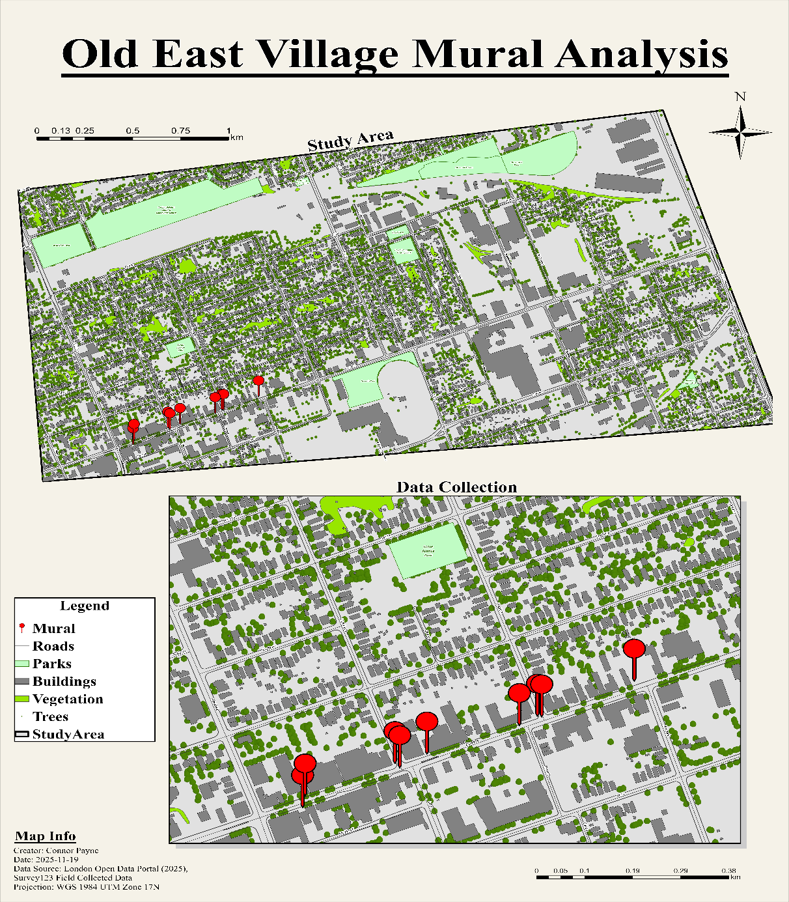
November 19, 2025

Figure 1: Final Map

Introduction
Urban murals have a significant impact on cultural expression, neighbourhood identity, and public space aesthetics. Murals serve as both community art projects and redevelopment initiatives in areas such as London, Ontario’s Old East Village. These pieces of art may deteriorate over time due to exposure to weather, pollution, physical wear, and human degradation. Frequent evaluations assist in determining areas that may require upkeep and the degree to which murals continue to fulfill their intended function.
This project’s objective was to use ArcGIS Survey123 to create and implement a mobile data-collection process to assess the state and features of murals in Old East Village. To create a modest but comprehensive dataset, the survey captured several characteristics, such as mural condition, visibility, wall material, mural type, age (if known) and degree of community involvement. The process comprised designing an XLSForm survey, gathering field data, and using a final map layout in ArcGIS Pro to visualize the findings.

Methodology
Survey Creation in Survey123 Connect
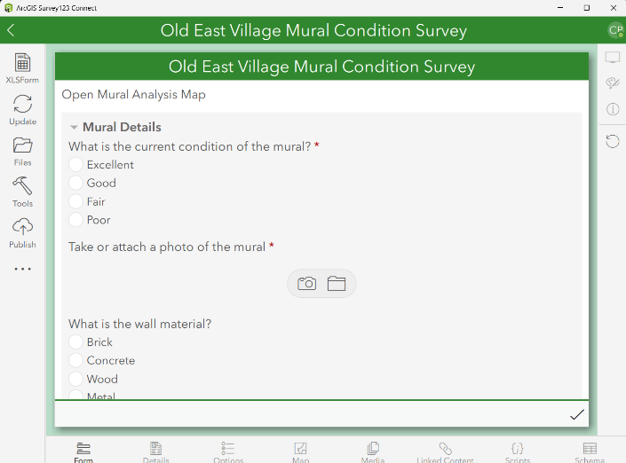
To tailor every question and response type, the survey was created using XLSForm in Survey123 Connect. A numerical visibility score, optional text options for artist name or year created, and select-one questions (such as mural condition, wall material, mural type, and community involvement) were all included in the form. To provide spatial reference for each mural input, the design additionally incorporated a geo-point query. To make sure the form functioned correctly on the mobile app, a few changes were required during setup to correct field names, group structures, and relevance logic.

Figure 2: Final Survey123 form

Field Data Collection
The Survey123 mobile app was used to gather data in the Old East Village neighbourhood. Every mural site was personally visited, and answers were inputted into the survey along with a photo of the mural and its GPS position. On-site subjective evaluations consisted of wall material, visibility scores, and condition ratings. When the year the mural was created as well as the artist were unknown, the fields were left with ‘Null’, allowing for date implantation in the future. A total of ten murals were examined and surveyed.
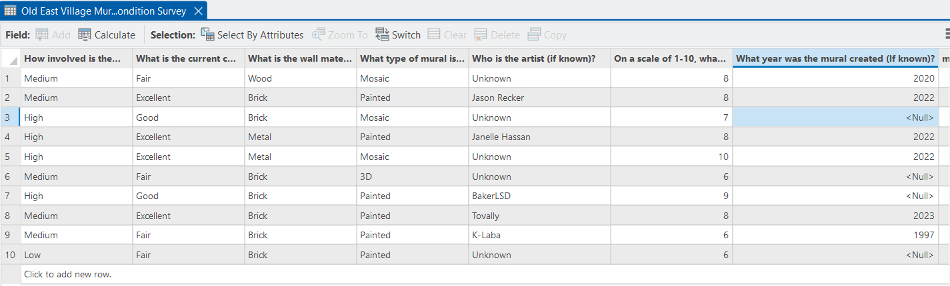
Figure 3: Cleaned attribute table after data validation
Data Management in ArcGIS Pro
The survey dataset was automatically added to the associated ArcGIS Online feature layer following collection. After that, the feature layer was imported into ArcGIS Pro for map creation and cleanup. Two duplicate fields related to visibility were present in the attribute table, one populated with accurate data and the other containing null values. The unused fields were hidden to limit any possibly confusion or data manipulation. Using information from the City of London open data portal, basemap layer and shapefiles representing roads, parks, vegetation, and building footprints were added for context. To make the mural points stand out, these layers were represented by subdued colors.
A two-frame layout was created for the final map; one zoomed in on Dundas Street, where the murals are concentrated, and another that depicts the larger study area. The layout was finished with a north arrow, scaling bars, a legend, a map information section.

Results
Overview of Field Observations
Ten murals in all were examined throughout the Old East Village route. Only a few murals were situated just north or south of the commercial strip, with the majority being focused along Dundas Street. Overall, the murals displayed a variety of visibility levels and conditions, but most of them were in Good or excellent shape.
Comments on Survey Experience
The revised layout made it easier to complete the survey in the field and kept the workflow structured. As we walked between locations, it was simple to compare murals, and the visibility score question performed well in practice. The only sporadic difficulty was determining the age of the mural in the absence of a plaque or other signage, which led to multiple spaces being left empty.
The ”community involvement” question was straightforward, but it was occasionally challenging to provide a decisive response without understanding the mural’s background. One mural was created in dedication of a historic building in the area known as the ‘Old East Village Hotel’ that was destroyed in 2009 and has been honoured since with artistic pieces in the community. In the field, it was consistently simple to identify the wall material and mural type questions.
Summary of Survey Findings
Mural Condition
- Excellent = 4 murals
- Good = 2 murals
- Fair = 4 murals
- Poor = 0 murals
Most murals have maintained their aesthetic and have not seen much wear, with no examples falling into the truly degraded and damaged category.
Visibility Score (1-10 scale)
The average visibility score was close to 8, with scores ranging from 6 to 10. This implies that the murals are typically visible from the street, which is in line with Old East Village’s emphasis on walkability and exposure of public art.
Community Involvement
- High = 3 murals
- Medium = 5 murals
- Low = 2 murals
The most prevalent assessment was medium engagement. Only a small number of murals seemed to be essential to the community’s identity or were regularly seen by the public.
Wall Material
With several murals, brick was the most popular surface, followed by metal and wood. This is consistent with the area’s physical environment, where the streetscape is dominated by brick commercial buildings.
Mural Type
Painted murals were the most frequent amongst the collected data, with a small number of mosaics and one 3D piece.
Map Based Results
To visualize the study region and the survey results, two maps were created:
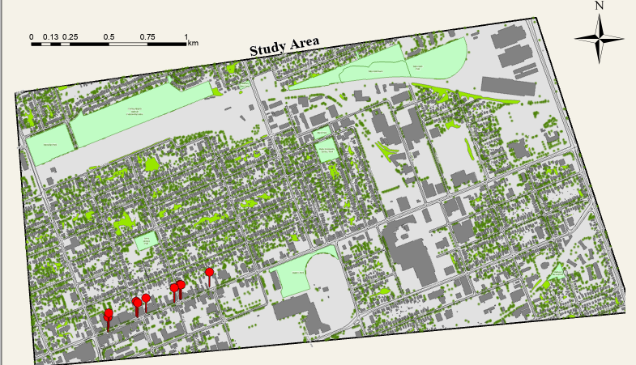
The Study Area Map shows the whole Old East Village Neighbourhood with an emphasis on the murals predominant clustering along Dundas Street. This highlights the corridors function as a business and cultural hub.

Figure 4: Main Study Area Map Frame
The Zoomed Frame Data Collection Map offers a close-up of the individual mural locations. The background layers (roads, buildings, parks, and trees) provide context for pedestrian movement and mural accessibility, while individual point symbols make it simple to identify each mural. By assisting in the comprehension of the spatial pattern of mural distribution throughout the neighbourhood, these visual representations supplement the attribute data.
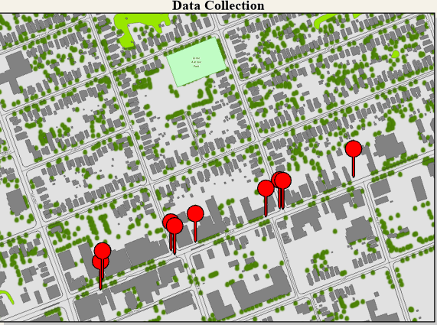

Figure 5: Concentrated Zoomed Map Frame
Conclusion
The project’s findings demonstrate that Old East Village murals are still noticeable across the neighbourhood and are generally in good condition. Only a small number of paintings displayed deterioration or fading, while the majority scored highly on visibility. A brief but significant glimpse of how public art is operating in this area of London is provided by the mix of mural condition, wall materials, community involvement, and visibility.
It became evident during the fieldwork that how these murals are maintained and experienced is influenced by the neighbourhood’s larger social milieu. Recent years have seen significant changes in Old East Village, especially with an increase in homelessness and drug abuse issues along Dundas Street. In several places, certain murals seemed to function as an unofficial message board that the homeless population in the area would use to pass along messages to one another. This implies that murals are engaging with the neighbourhood in ways that go beyond their initial creative objective, even while it does not intrinsically degrade the artwork. These findings highlight the necessity of continuing maintenance planning that considers the murals’ physical state as well as the social context in which they are located.
Overall, this project showed the benefits of gathering and visualizing mural data in an organized workflow using ArcGIS Survey123 and ArcGIS Pro. If the study were to be expanded in the future, it might be improved by gathering more specific data about the history of murals, introducing uniform techniques for grading visibility, and doing updates over several seasons to evaluate change over time. The project effectively illustrates how public art may reflect both the cultural richness and the changing issues prevalent within an urban community, despite the small sample size.

